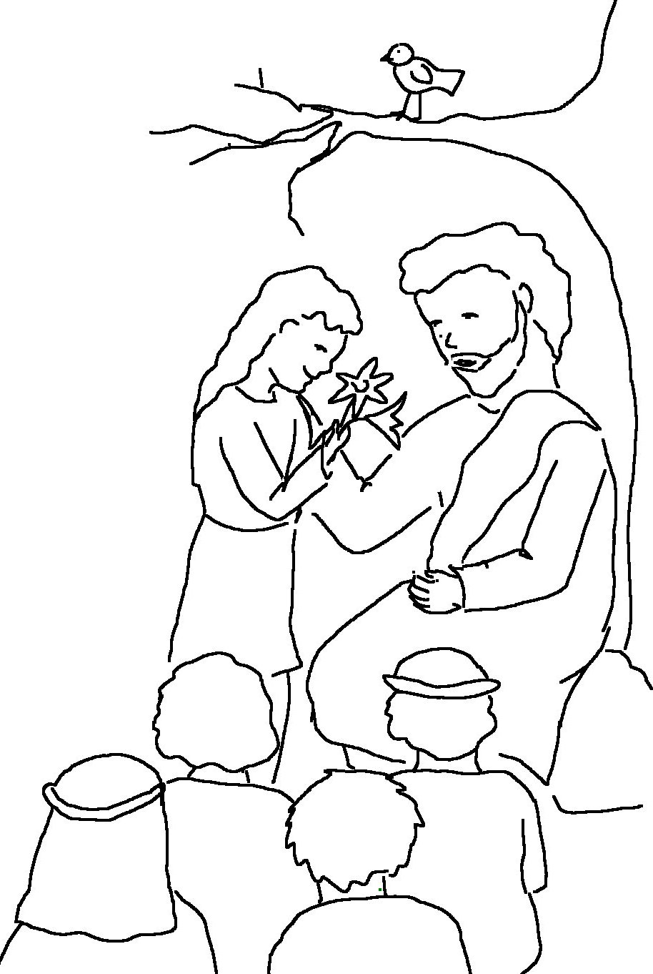

The Lord is my shepherd;
I have all that I
need.
Psalms 23:1 _{NLT}

